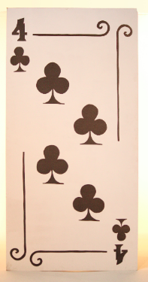

b'4 clubs\n' (score = 0.30871)  
b'6 spades\n' (score = 0.10156)  
b'7 clubs\n' (score = 0.07894)  
b'ace spades\n' (score = 0.05341)  
b'2 spades\n' (score = 0.05284)  
  
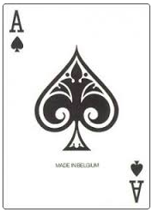  
  
b'ace spades\n' (score = 0.90634)  
b'ace hearts\n' (score = 0.03902)  
b'4 spades\n' (score = 0.00750)  
b'4 clubs\n' (score = 0.00716)  
b'9 spades\n' (score = 0.00693)  
  
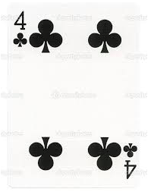  
  
b'4 clubs\n' (score = 0.61415)  
b'ace hearts\n' (score = 0.10518)  
b'4 spades\n' (score = 0.06681)  
b'2 hearts\n' (score = 0.05184)  
b'9 spades\n' (score = 0.03055)

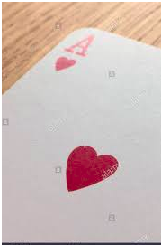

b'ace hearts\n' (score = 0.45255)  
b'2 hearts\n' (score = 0.22186)  
b'ace diamonds\n' (score = 0.12385)  
b'2 spades\n' (score = 0.04014)  
b'4 spades\n' (score = 0.03450)

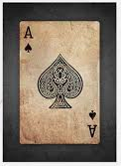  
  
b'ace spades\n' (score = 0.66691)  
b'king diamonds\n' (score = 0.11923)  
b'king spades\n' (score = 0.06776)  
b'ace diamonds\n' (score = 0.02684)  
b'7 spades\n' (score = 0.01854)

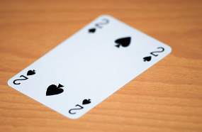

b'2 spades\n' (score = 0.79940)  
b'3 spades\n' (score = 0.13027)  
b'5 spades\n' (score = 0.02325)  
b'2 clubs\n' (score = 0.02149)  
b'3 clubs\n' (score = 0.00814)

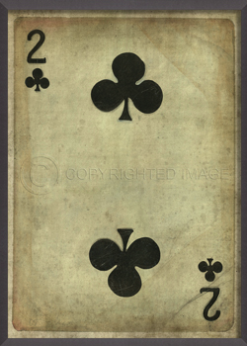

b'2 clubs\n' (score = 0.62471)  
b'3 clubs\n' (score = 0.09453)  
b'2 spades\n' (score = 0.03627)  
b'10 clubs\n' (score = 0.03306)  
b'4 clubs\n' (score = 0.02452)

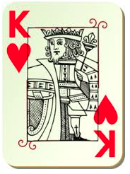

b'king hearts\n' (score = 0.28723)  
b'jack diamonds\n' (score = 0.22032)  
b'4 hearts\n' (score = 0.08418)  
b'queen spades\n' (score = 0.06742)  
b'ace diamonds\n' (score = 0.03004)

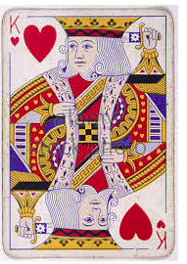

b'king hearts\n' (score = 0.69048)  
b'king diamonds\n' (score = 0.15060)  
b'queen diamonds\n' (score = 0.09313)  
b'queen hearts\n' (score = 0.01709)  
b'jack hearts\n' (score = 0.01032)

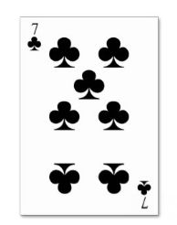

b'7 clubs\n' (score = 0.62282)  
b'10 clubs\n' (score = 0.28174)  
b'3 clubs\n' (score = 0.04706)  
b'6 clubs\n' (score = 0.02405)  
b'6 spades\n' (score = 0.00639)

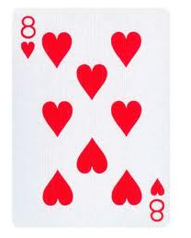

b'8 hearts\n' (score = 0.90390)  
b'7 hearts\n' (score = 0.02438)  
b'9 hearts\n' (score = 0.01850)  
b'10 hearts\n' (score = 0.01588)  
b'6 diamonds\n' (score = 0.00778)